***Question 1:***

* In this problem, we are creating a program that accepts input as text or number from the user and translate them into morse code. Likewise, the program can also accept morse code as input and translate them to text or number.
* In order to solve this problem, First we need to create a dictionary. In this dictionary, alphabet characters and numbers are the keys. Each key will be assigned the correct morse code as its value. Next, we create a function to encode text to morse code. At the beginning of this function, we will create a variable to store all the translated morse code. Then, it will loop through each character in the input text, if the character isn’t a single space, it will check the dictionary to find the legit morse code with that character and add them to the variable we created. If the character is a single space, it will add a three-character space to the variable, indicate it’s a space between two different words. The function will continue until the loop reach the last character of the text. To decode morse code to text, we follow quite similar steps as the encode function. At the start, we create 2 variables, a “word” variable to store a word in morse code style, and a “text” variable to store these words to make it a completed text. Next, it will loop through each character of the input, if that character is not a space, it will add that character to the “word” variable. It will keep adding morse code to the “word” variable until it finds a character that is a three-character space, which is a space between words. Now, we will reverse the dictionary to find the legit alphabet letter or number for the morse code we stored in the “word” variable. The function will continue doing so until it reaches the last space of the input.
* Here is a sample output of the program:  
  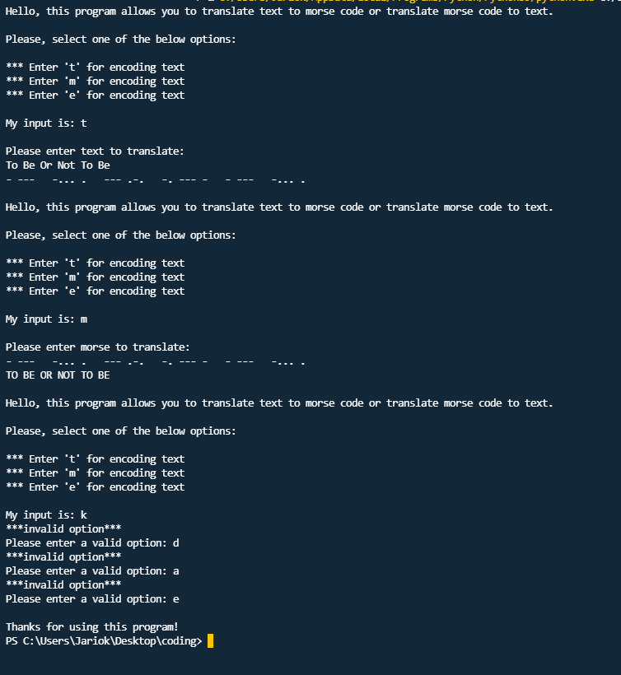

***Question 2:***

* In this problem, we are creating a program that keeps names withtheir corresponding email addresses and allows users to modify the information the way they want to.
* In order to make this program works efficiently, first we need to create a dictionary to keep these information as key-value pairs and store them in a .txt file. The name will be the key, and the email address will be its corresponding value. Next, we’re gonna create 6 functions to modify the information we store in the dictionary. This includes: load information, save information, look up information, add information, change information, and delete information. To load information, first we need to create a variable to read a file. Then, for each line in the file, it will be separated by a comma, the name is what comes before the comma and the email is what comes after the comma. Then we store them to the dictionary we created. To save information, we create a variable to write to a file, and for each items in the dictionary, they will be written onto the .txt file. Each key-value pair will be separated by a comma. To look up information, the function will require a name as a parameter, then it will load information to the dictionary using the “load info” function, after that it will check to see if the name we parse into the look up function exists in the dictionary. Add information function will require 2 parameters, a name and an email. Then we store them to the dictionary and use save information function to update the dictionary. To change information, we parse a name as a parameter, then we will ask user to input a new email address for that name. Once done, the add information function will be used to update the dictionary. Finally, to delete an information, the function will take a name as a parameter. Then, using load information function to load up the dictionary. Next, it will check to see if the name existed in the dictionary. If the name exists, it will delete that key-value pair and use save information function to update the dictionary. Now, in the main function, we will use a while loop to keep the program running until the user decides when to exit. And for each of the 6 modification function, we created above, whichever requires parameter, we will ask for user input and use if-else statement to display the result.
* Here is a sample output: 